Arabic Language Basics

Section: L01

Assignment Date: 6/09/2021

Name: Talha Abdullah Punjabi

QUID: 201903446

Unit 4- New Vocabulary

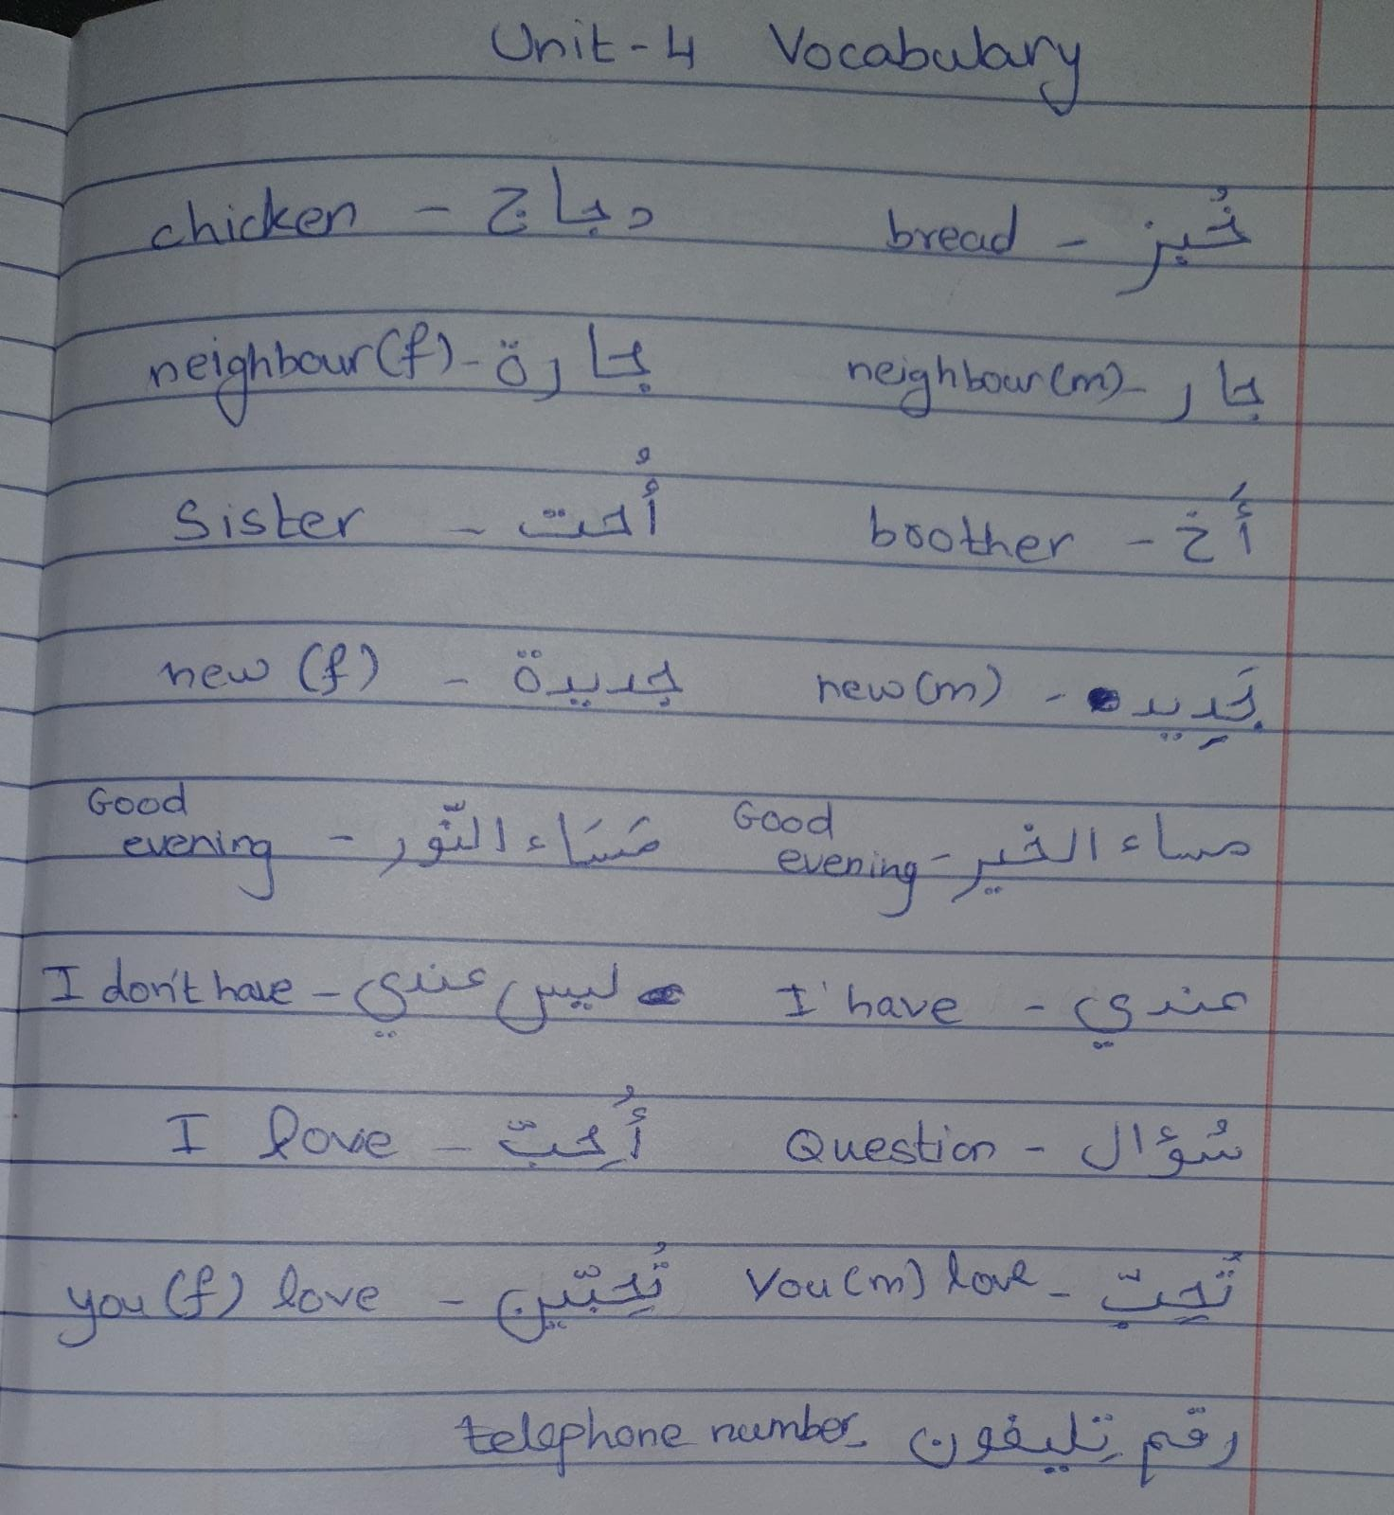

Writing Letters

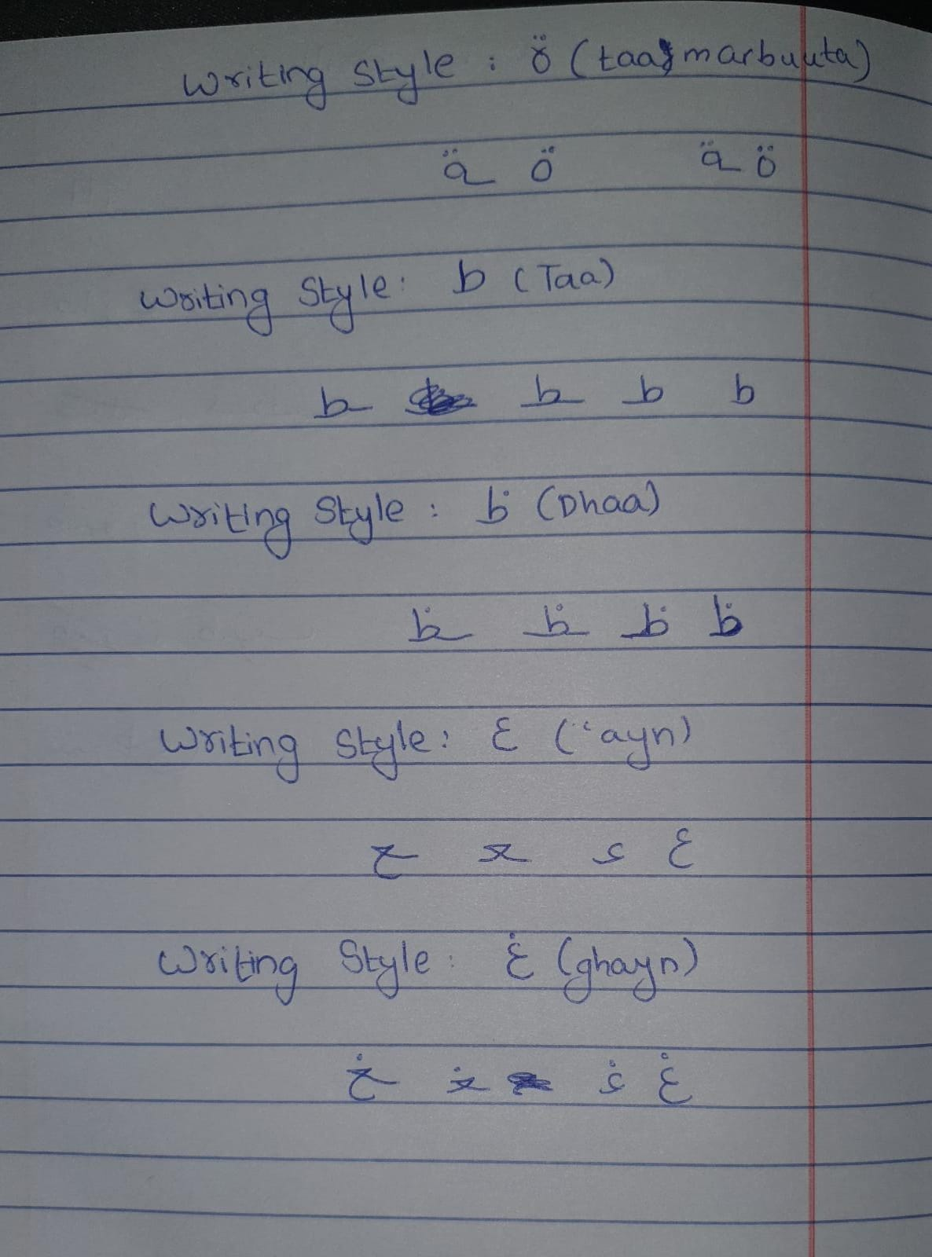

Unit 6- Drill 6

